

**THE UNIVERSITY OF TEXAS AT ARLINGTON, TEXAS  
DEPARTMENT OF ELECTRICAL ENGINEERING**

**EE 5321 - 001**

**OPTIMAL CONTROL**

**HW # 5**

**ASSIGNMENT**

**by**

**SOUTRIK MAITI**

**1001569883**

**Presented to**

**Prof. Michael Niestroy**

**April 15,2018**

Problem 1:

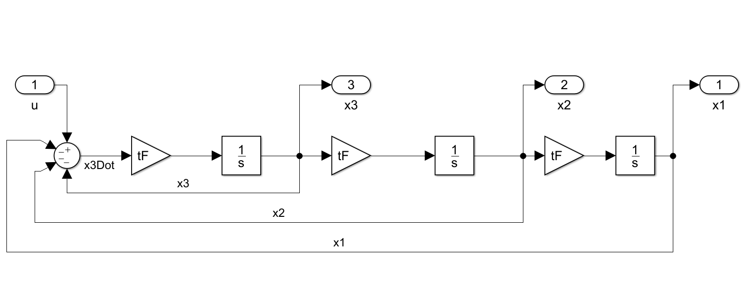

*Fig1.1.1 Simulink Diagram for Linear Bang-Bang Control*

1. When initial state : (x1(0), x2(0), x3(0)) = (1,0,0)

When the control is constrained to +/-1.

Initial tF = 3

*MATLAB Code*:

tF = randi(6);

t = 0:0.025:1;

u = 0.01* ones(length(t),1);

u(end+1) = tF;

%% Optimization

lb = -1 * ones(length(t),1);

ub = 1 * ones(length(t),1);

lb(end+1) = 1;

ub(end+1) = 10;

options = optimset('Display', 'iter', 'TolCon', 1e-5,'TolFun', 1e-5, 'PlotFcns','optimplotx', 'MaxFunEvals', 4400);

[yF,cost] = fmincon('p1_cost',u,[],[],[],[],lb,ub,'p1_constraint',options);

%% Plotting

tF = yF(end)

[tout,yout] = sim('bangBang',1,[],[t' yF(1:end-1)]);

figure;

plot(t*tF,[yout(:,1),yout(:,2),yout(:,3)]);

legend('x1','x2','x3'); title('State time history');

grid;

figure;

plot(t*tF,yF(1:end-1))

title('Control time history')

*cost function:*

function cost = p1_cost(u)

cost = u(end);

end

*constraint function:*

function [cineq, ceq] = p1_constraint(p)

cineq = [];

assignin('base', 'tF', p(end));

t=[0:0.025:1]';

u=[p(1:end-1)];

[tout,yout]=sim('bangBang',1,[],[t u]);

ceq(1) = yout(end,1) ;

ceq(2) = yout(end,2) ;

ceq(3) = yout(end,3) ;

end

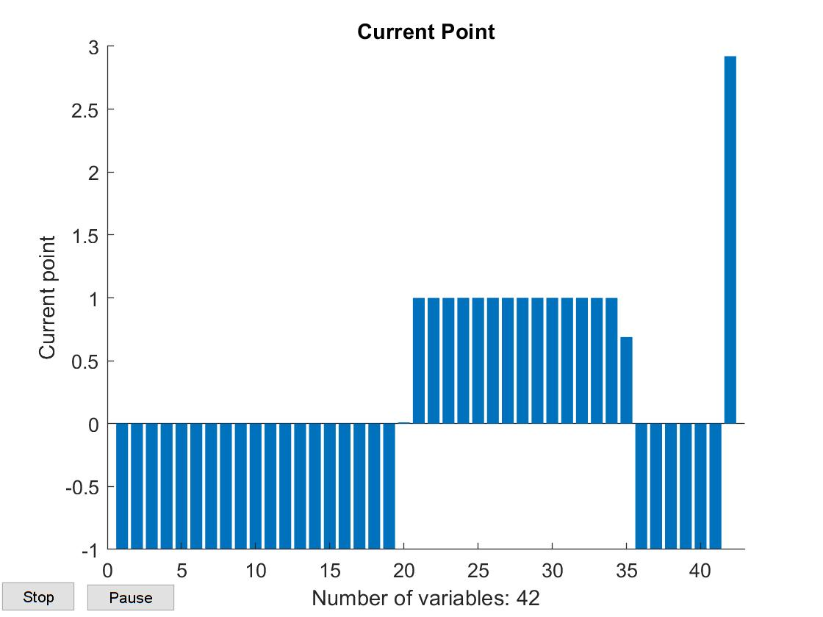

*Fig 1.1.2 Optimization Plot*

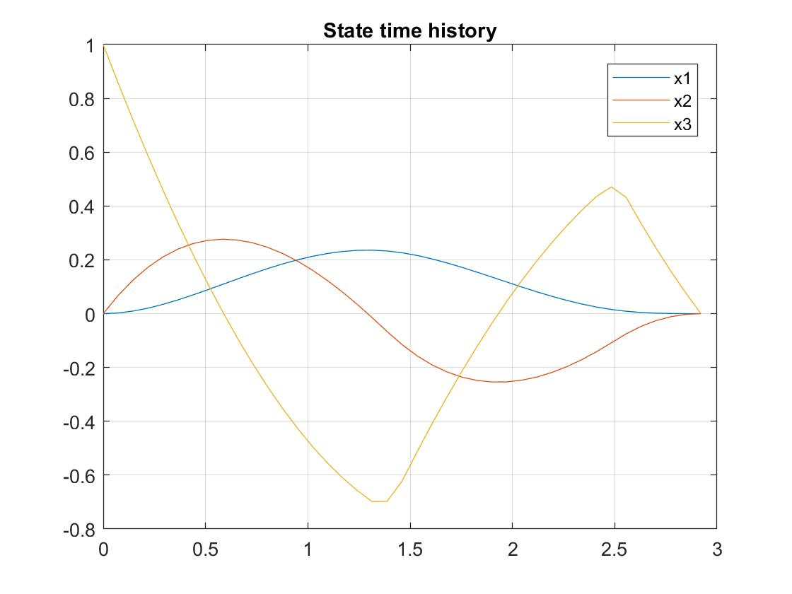

*Fig 1.1.3 State Time history*

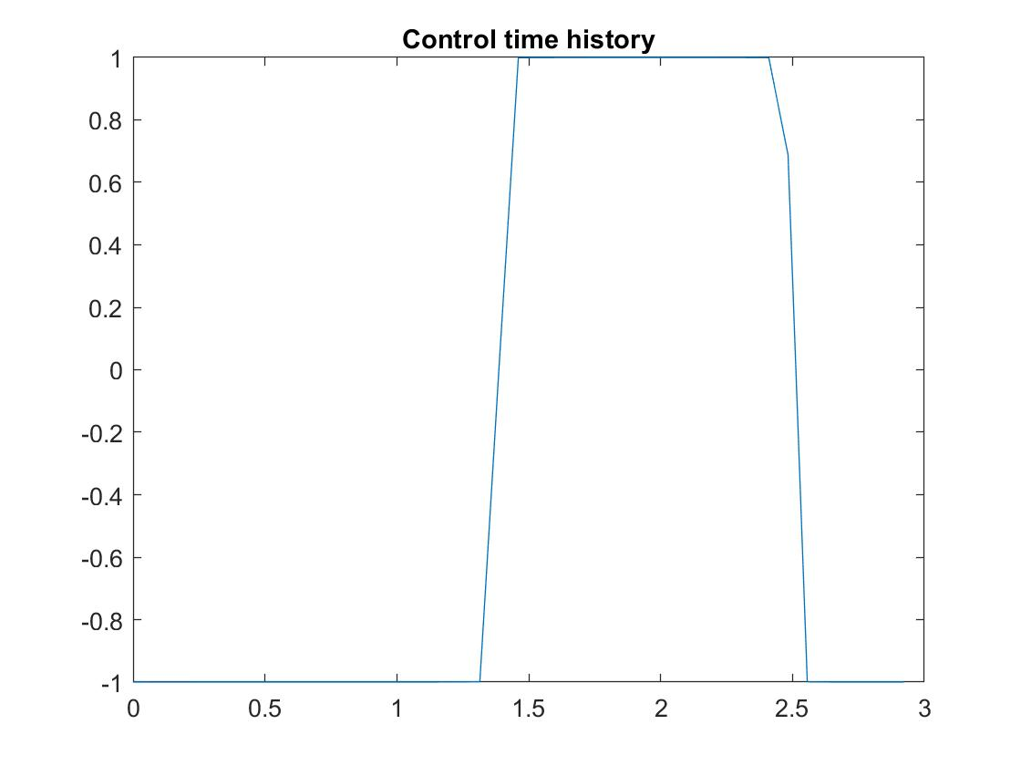

*Fig 1.1.4 Control Time History*

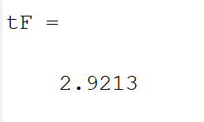

*The switching occurs twice for this set of initial conditions of states.*

1. When the control is constrained to +/-0.75

Initial tF = 5

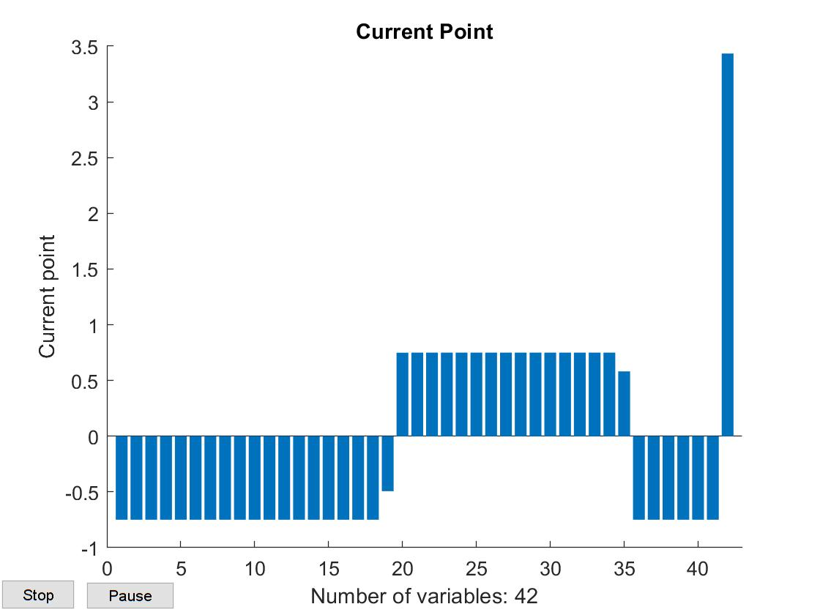

*Fig 1.2.1 Optimization Plot*

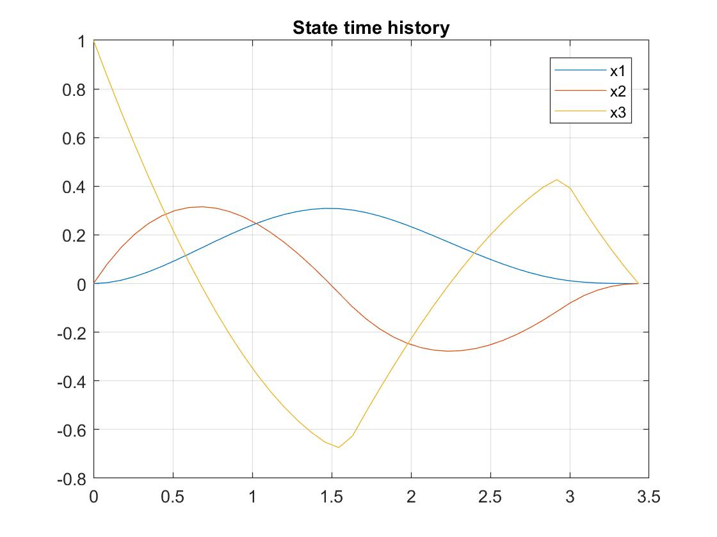

*Fig 1.2.2 State Time history*

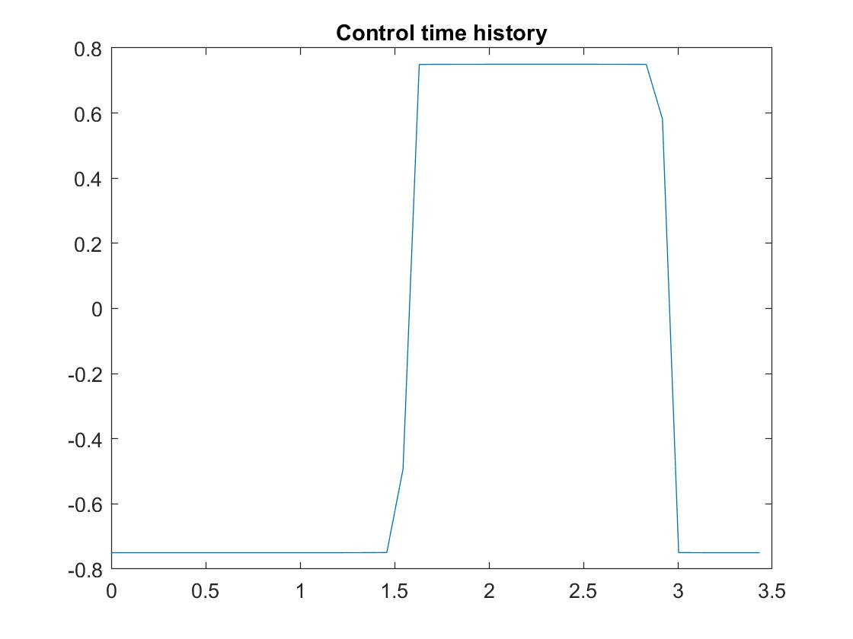

*Fig 1.2.3 Control Time History*

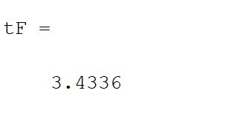

*The switching occurs twice when the control constraints are +/-0.75.*

1. When the control is constrained to +/-0.5

Initial tF = 5



*Fig 1.3.1 Optimization Plot*



*Fig 1.3.2 State Time history*



*Fig 1.3.3 Control Time History*

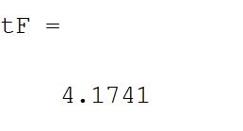

*The switching occurs twice when the control constraints are +/-0.5.*

1. When initial state: (x1(0), x2(0), x3(0)) = (1,1,1)

Control constrained to +/-1.0

Initial tF = 6

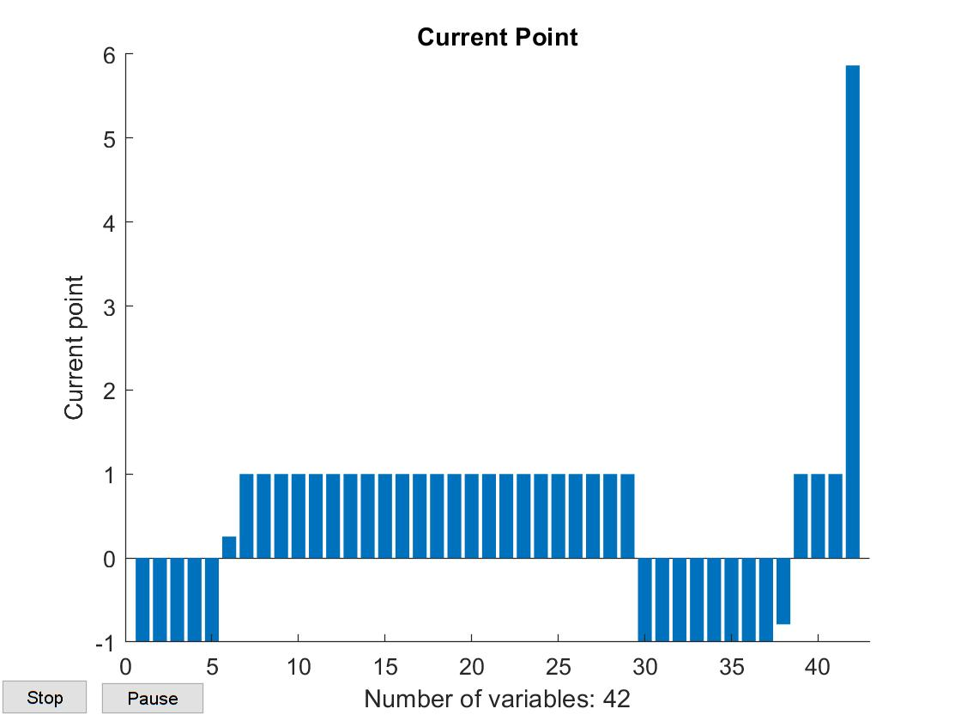

*Fig 1.4.1 Optimization Plot*

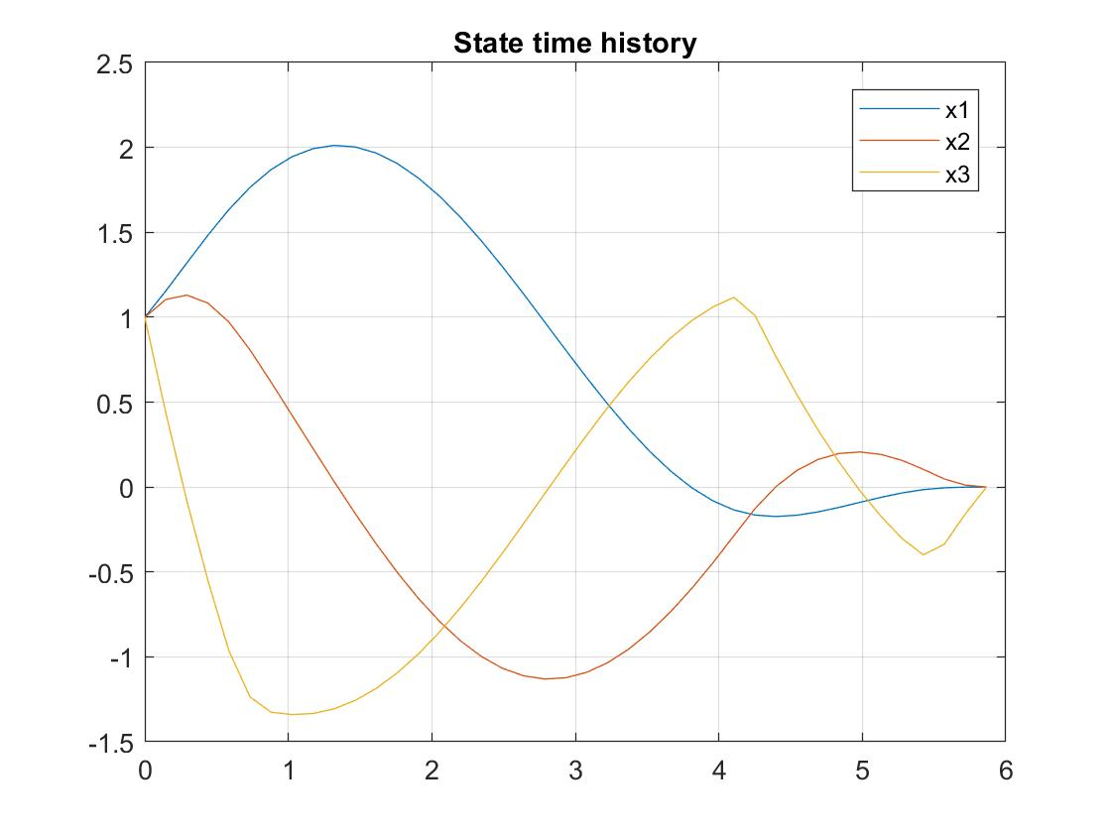

*Fig 1.4.2 State Time history*

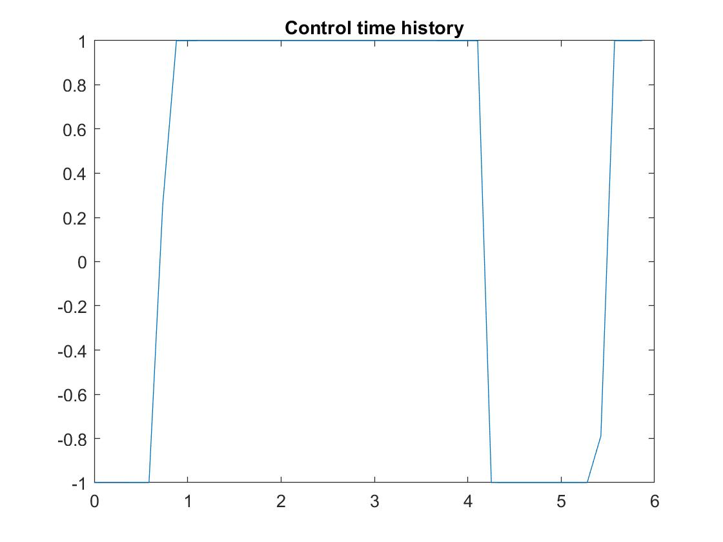

*Fig 1.4.3 Control Time History*

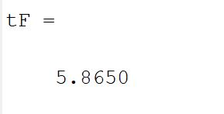

*The switching occurs thrice when the initial conditions are (1,1,1).*

Problem 2:

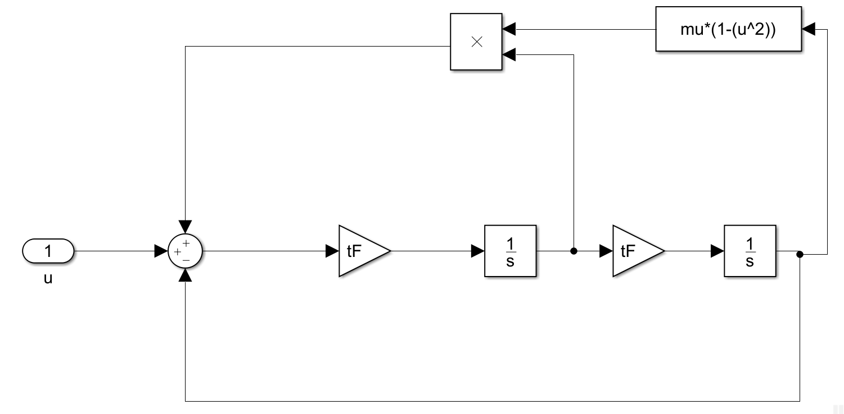

*Fig 2.1.1 Simulink Diagram for Nonlinear Van der Pol*

1. When the upper and lower bounds of the control are +/-10

MATLAB Code:

tF = 4;

mu = 5;

t = 0:0.02:1;

u = 0.05* ones(length(t),1);

u(end+1) = tF;

%% Optimization

lb = -10 * ones(length(t),1);

ub = 10 * ones(length(t),1);

lb(end+1) = 0.2;

ub(end+1) = 30;

options = optimset('Display','iter','TolCon',1e-4,'TolFun',1e-4,'PlotFcns','optimplotx', 'MaxFunEvals',5000,'Algorithm','interior-point');

[yF,cost] = fmincon('VDP_cost',u,[],[],[],[],lb,ub,'VDP_constraint',options);

%% Plotting

tF = yF(end)

[tout,yout] = sim('VDP1',1,[],[t' yF(1:end-1)]);

figure;

plot(yout(:,1),yout(:,2));title('Phase plane plot');grid on;

figure;

plot((1:201)*tF,yout);title('State time history');legend('x1','x2');grid on;

figure;

plot(t*tF,yF(1:end-1))

title('Control time history');

*cost function:*

function cost = VDP_cost(u)

cost = u(end);

end

*Constraint function:*

function [cineq, ceq] = VDP_constraint(p)

cineq = [];

assignin('base', 'tF', p(end));

tau=[0:0.02:1]';

u=[p(1:end-1)];

[tout,yout]=sim('VDP1',1,[],[tau u]);

ceq(1) = yout(end,1)-3 ;

ceq(2) = yout(end,2) ;

end

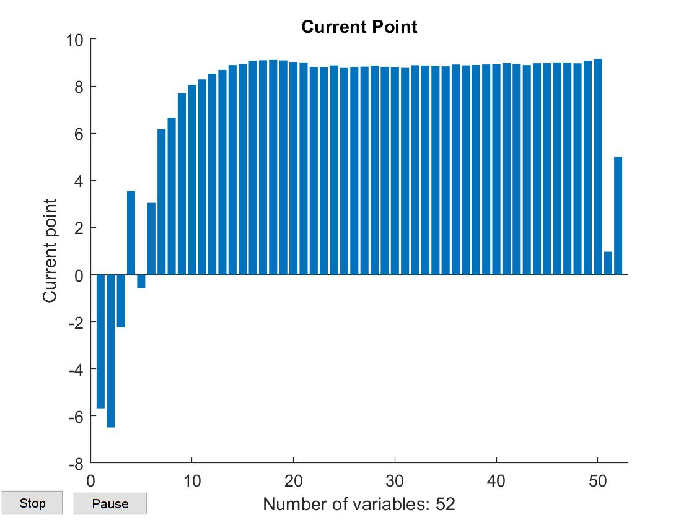

*Fig 2.1.2 Optimization Plot*

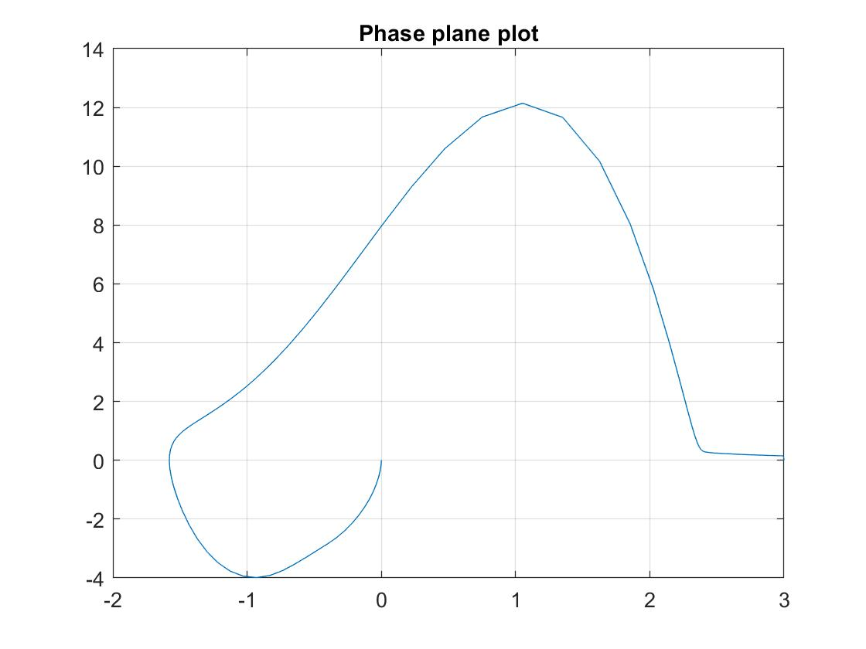

*Fig 2.1.3 Phase Plane Plot*

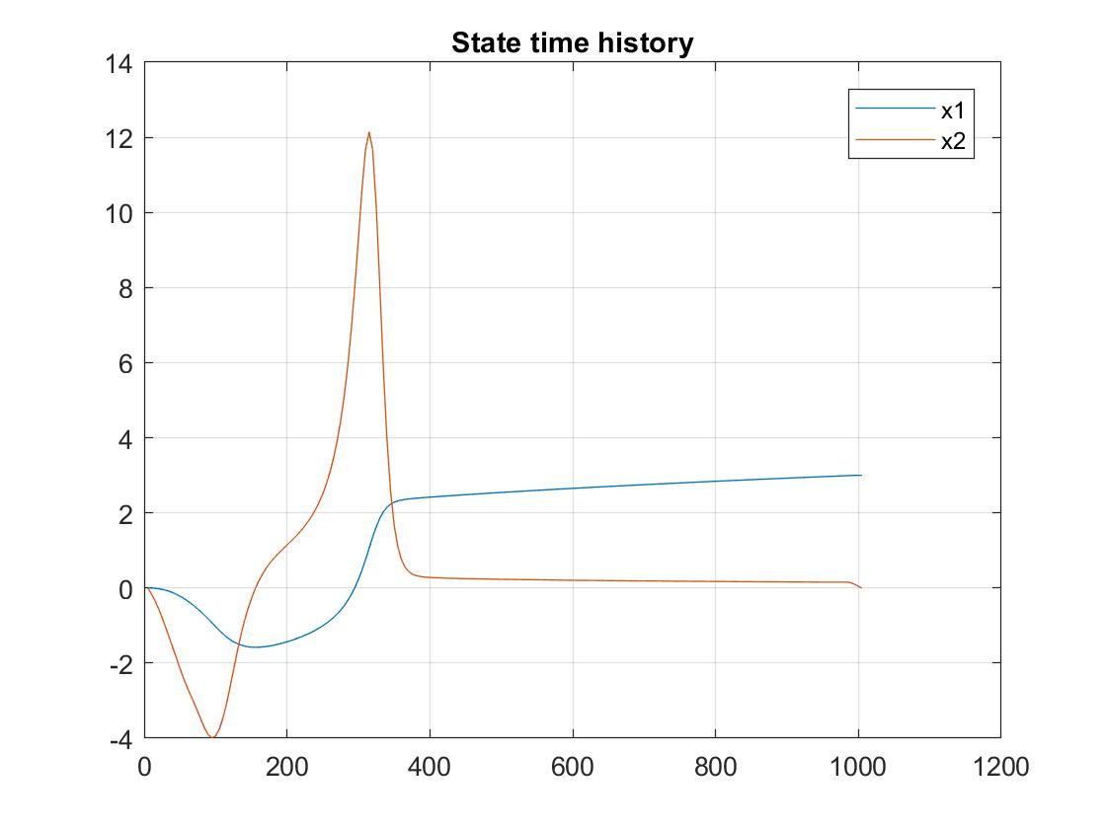

*Fig 2.1.4 State Time history*

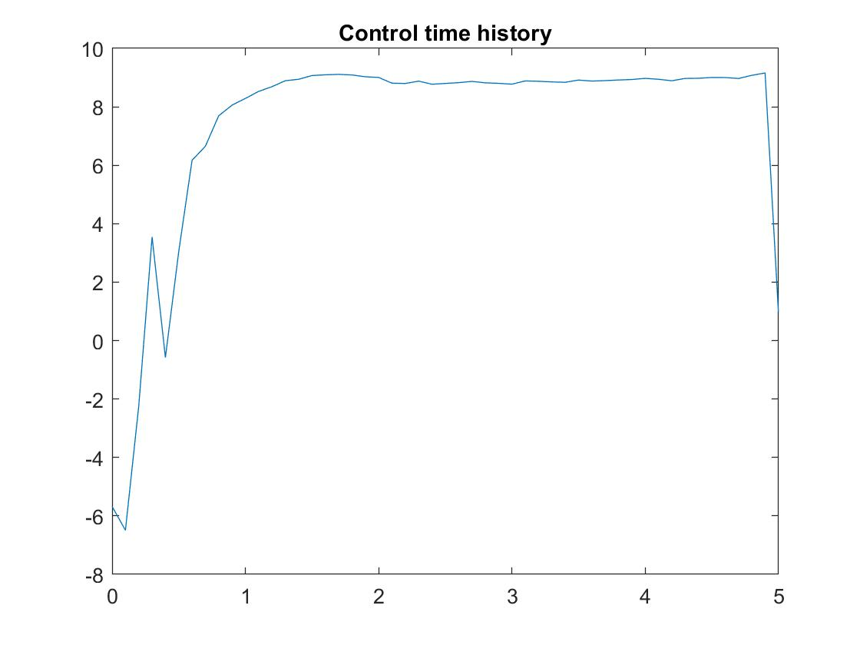

*Fig 2.1.5 Control Time history*

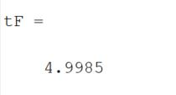

1. When the upper and lower bounds of the control are +/-7

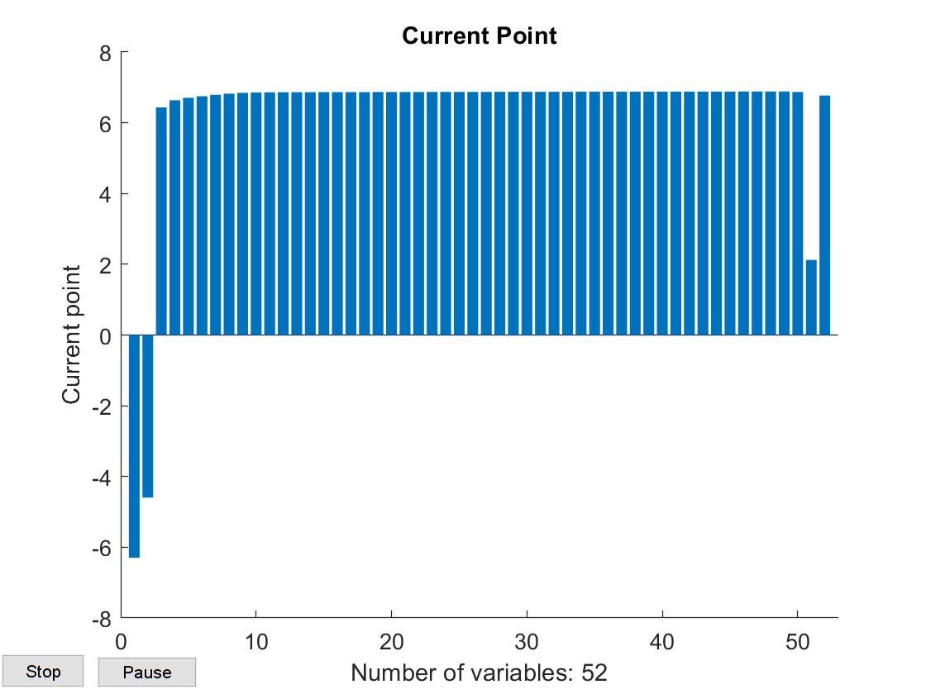

*Fig 2.2.1 Optimization Plot*

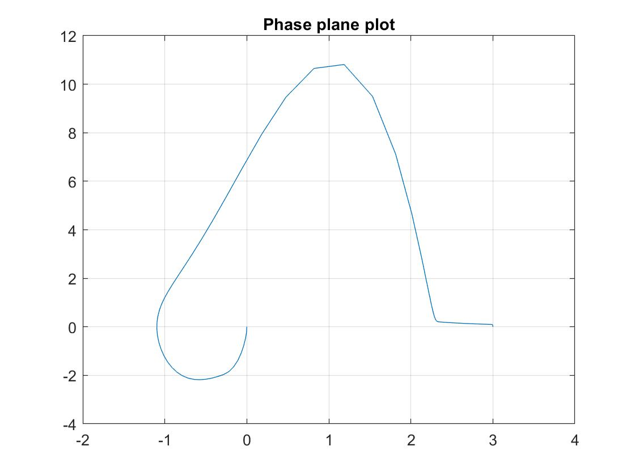

*Fig 2.2.2 Phase Plane Plot*

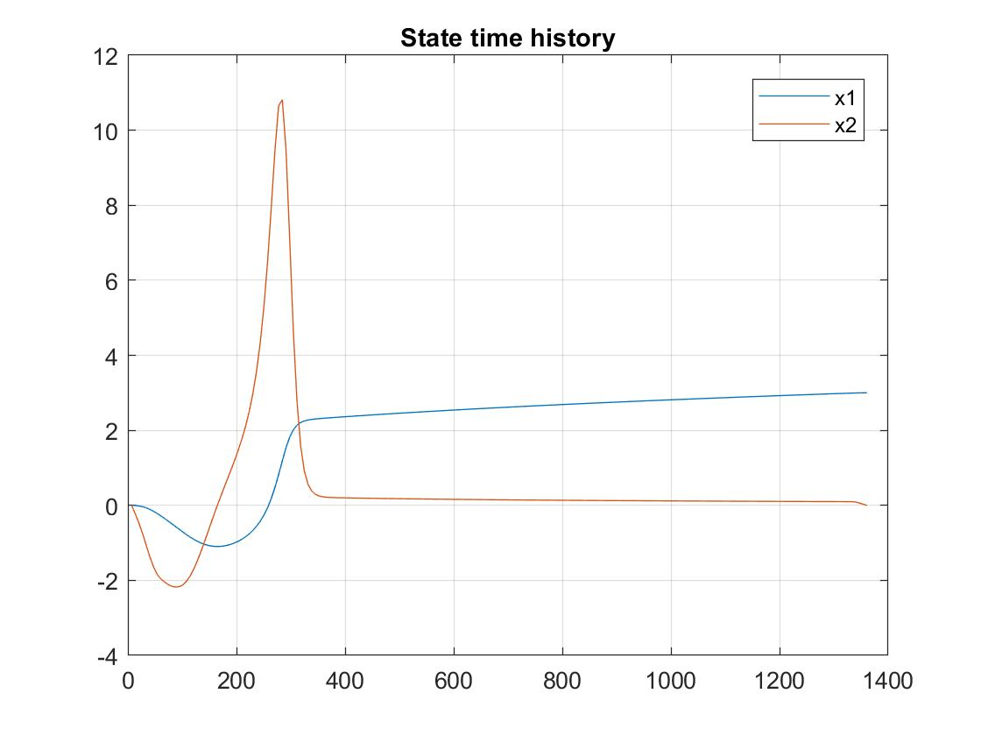

*Fig 2.2.3 State Time history*

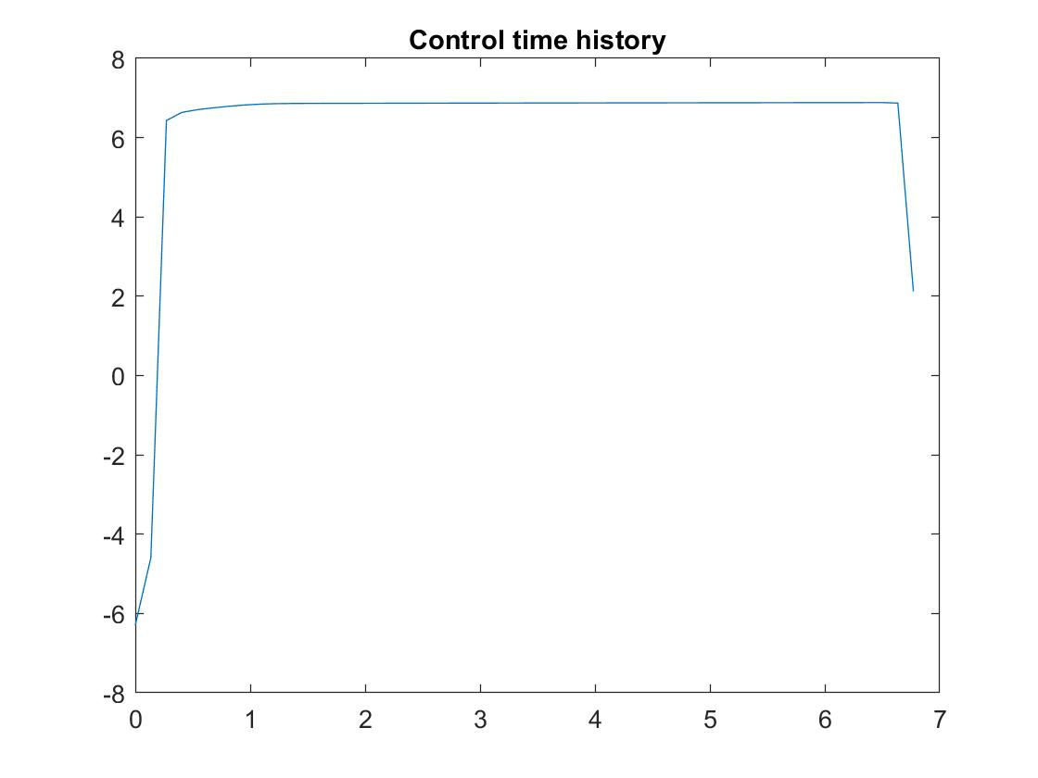

*Fig 2.2.4 Control Time history*

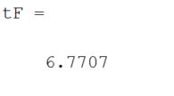

1. When the upper and lower bounds of the control are +/-5

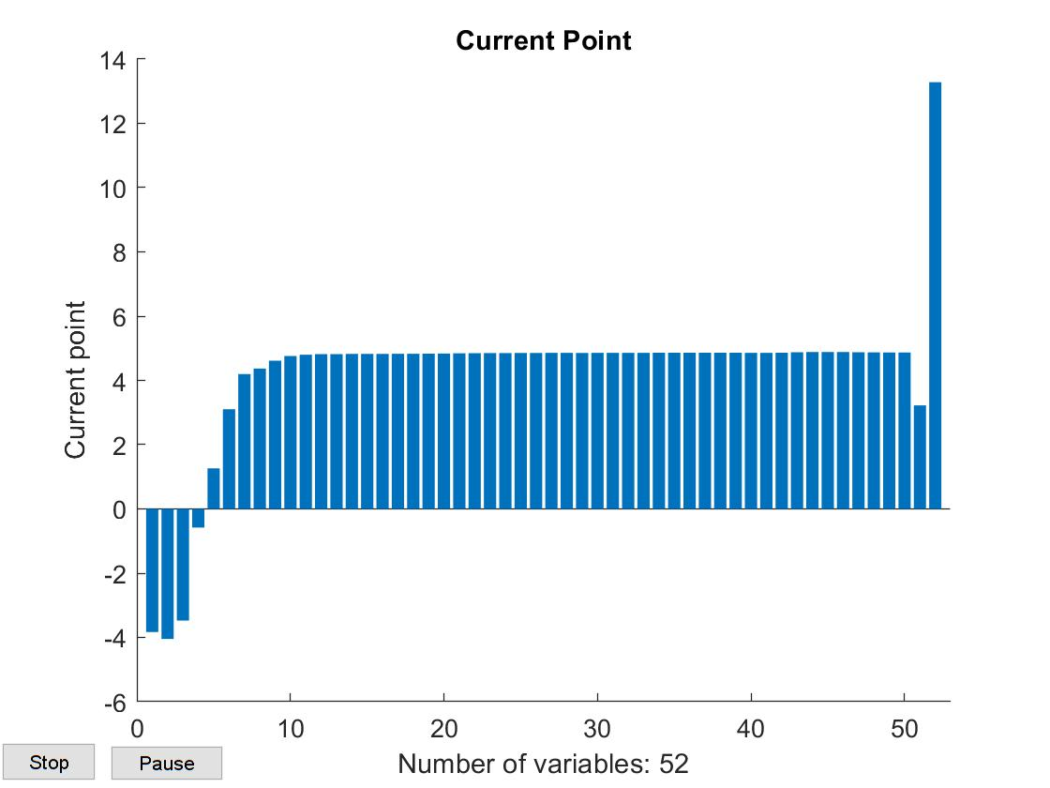

*Fig 2.3.1 Optimization Plot*

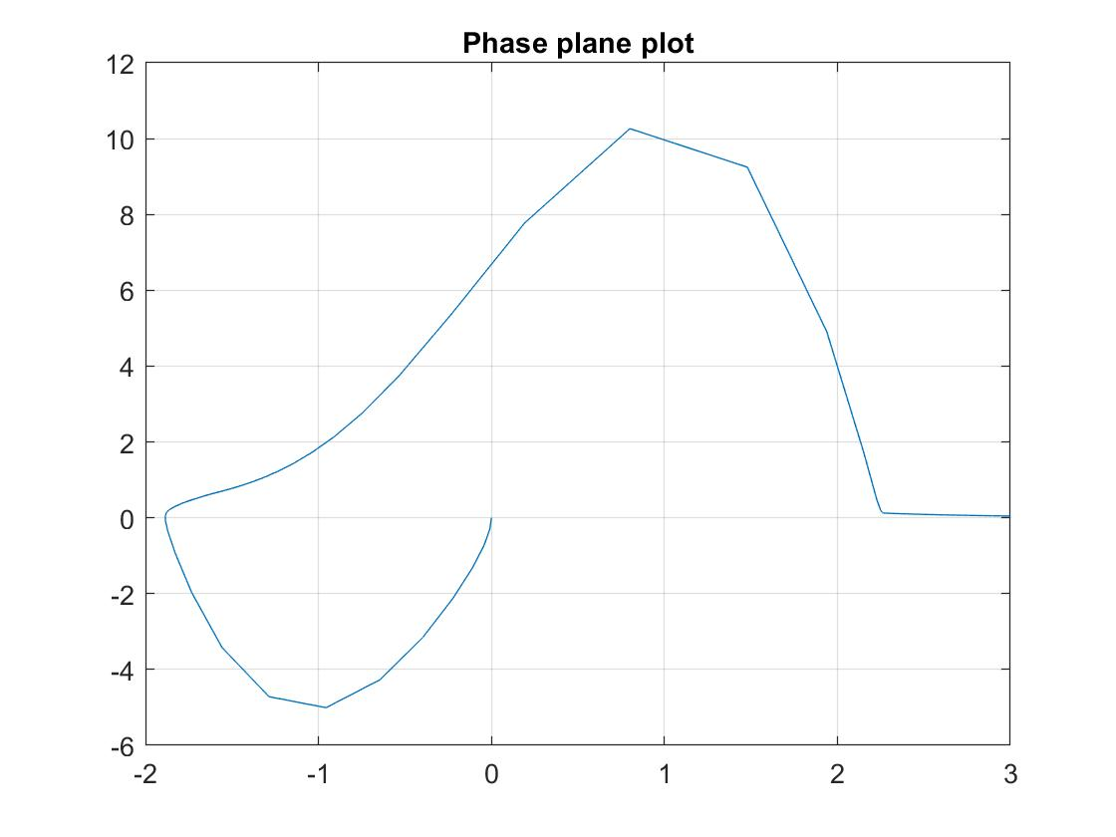

*Fig 2.3.2 Phase Plane Plot*

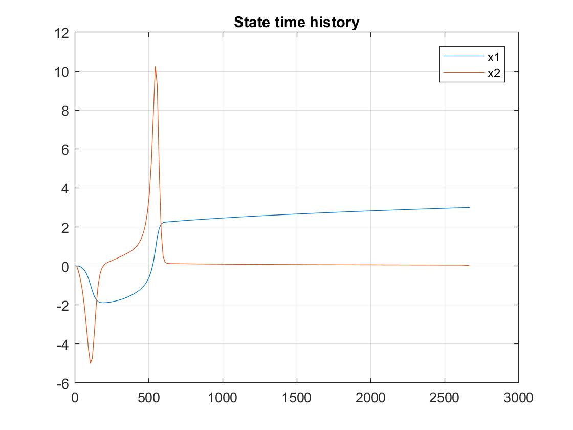

*Fig 2.3.3 State Time history*

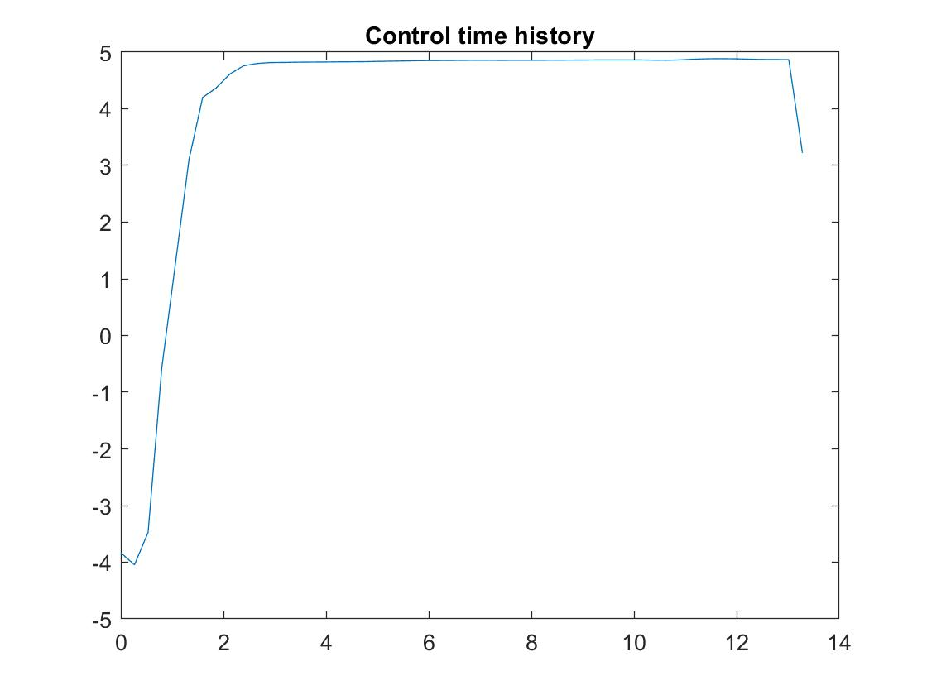

*Fig 2.3.4 Control Time history*

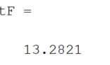

1. Comparison of the bounds the final optimal time:

|  |  |
| --- | --- |
| *Control Bounds* | *Optimal final time* |
| +/-10 | 4.9985 |
| +/-7 | 6.7707 |
| +/-5 | 13.2821 |

We can see that as the control bounds decrease, the optimal final time increases. We also notice that the tighter the bounds are the more it takes time to reach the final values.

The control time history also became smoother as the bounds decreased. It was jagged in the beginning but started smoothening out in the second and the third case.